24CSI024 - Data Structures and Algorithms
Unit 1: Introduction to Data Structures and Algorithms Arrays and Array-Based Techniques
Worksheet - 13.07.2026

Problem 1 - Leaderboard Updates

Problem Statement
Meera is building a live leaderboard for a coding contest. She starts with an array of player scores. During the contest she receives update operations. Each operation either inserts a new score at a given position or deletes the score at a given position. She wants the final leaderboard array after all operations have been applied in order.

Input Format
- The first line contains two space-separated integers n and q, the number of elements in the initial array and the number of operations.
- The second line contains n space-separated integers, the initial array. If n = 0, this line is empty.
- Each of the next q lines describes one operation: I pos val inserts val at index pos, and D pos deletes the element at index pos.

Output Format
- Print the final array as space-separated integers on one line after all operations have been applied.
- If the resulting array is empty, print Empty Array.

Code Constraints
- 0 <= n <= 100
- 1 <= q <= 100
- The array size never exceeds 200 at any point.
- Every index in an operation is valid when that operation is applied.

Sample Test Cases

Input 1:
5 2
10 20 30 40 50
I 2 99
D 0

Output 1:
20 99 30 40 50

Input 2:
3 3
5 6 7
D 1
D 0
I 0 100

Output 2:
100 7

Solution

Aim
To write a C program that updates a leaderboard by handling insert and delete operations, and then displays the final list of scores in order.

Pseudocode

Read n and q.
Read the initial score array.
Repeat q times: read the operation type.
If the operation is insert, shift elements to the right and place the new value at the given position.

If the operation is delete, shift the following elements to the left. Print the final array, or print Empty Array if no elements remain.

C Program
#include <stdio.h>

int main() {
scanf("%d %d", &n, &q);

int arr[200];
for (int i = 0; i < n; i++) { scanf("%d", &arr[i]);
}

for (int i = 0; i < q; i++) { char op;
int pos, val; scanf(" %c", &op);

if (op == 'I') {
scanf("%d %d", &pos, &val);
for (int j = n; j > pos; j--) {
arr[j] = arr[j - 1];
}
arr[pos] = val; n++;
} else if (op == 'D') {
scanf("%d", &pos);
for (int j = pos; j < n - 1; j++) { arr[j] = arr[j + 1];
}
n--;
}
}

if (n == 0) {
printf("Empty Array\n");
} else {
for (int i = 0; i < n; i++) { printf("%d", arr[i]);

}
printf("\n");
}
return 0;
}

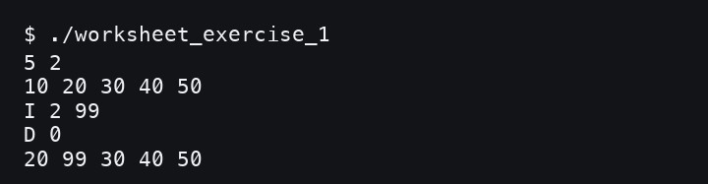
Screenshot of the Output
- Result
The leaderboard was updated correctly after applying the insert and delete operations.

Problem 2 - Sensor Window Sum

Problem Statement
Rohan is processing readings from a linear sensor array. His access logic may only move through memory using pointer arithmetic, so array-indexing syntax is not used in the read logic. Given the readings and an inclusive index range [L, R], he must compute the sum of readings from index L to R.

Input Format
- The first line contains an integer n, the number of sensor readings.
- The second line contains n space-separated integers, the sensor readings.
- The third line contains two space-separated integers L and R, the inclusive range to sum.

Output Format
- Print a single integer: the sum of readings from index L to R inclusive.

Code Constraints
- 1 <= n <= 1000
- 0 <= L <= R <= n - 1
- Each reading fits within a 32-bit signed integer.
- The element-access logic must use pointer arithmetic, for example *(ptr + i).

Sample Test Cases

Input 1:
6
10 15 20 25 30 35
1 4

Output 1:
90

Input 2:
4
100 200 300 400
0 0

Output 2:
100

Solution

Aim
To write a C program that finds the sum of sensor readings in a given range by using pointer arithmetic instead of array indexing.

Pseudocode

Read n and store the sensor readings. Read the range L and R.
Create a pointer that points to the first element.
Move through the required positions using pointer arithmetic. Add all readings from L to R.
Print the final sum.

C Program
#include <stdio.h>

int main() { int n;
scanf("%d", &n);

int readings[1000]; int *ptr = readings;

for (int i = 0; i < n; i++) { scanf("%d", ptr + i);
}

int l, r;

scanf("%d %d", &l, &r);

long long sum = 0;
for (int i = l; i <= r; i++) { sum += *(ptr + i);
}

printf("%lld\n", sum); return 0;
}

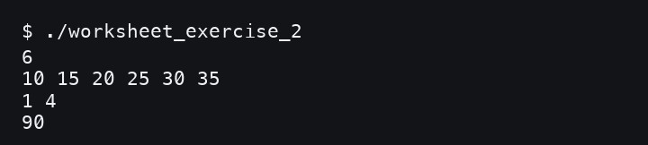
Screenshot of the Output
- Result
The sum of the selected sensor window was calculated correctly using pointer arithmetic.

Problem 3 - Warehouse Grid Lookup

Problem Statement
Kabir manages a warehouse whose shelves are arranged in a grid of R rows and C columns. To save memory, the inventory system stores the grid as one flat 1D array in row-major order. For every query, he must compute the correct flat index and report both the index and the value stored there.

Input Format
- The first line contains two space-separated integers R and C, the number of rows and columns.
- The second line contains R x C space-separated integers stored in row-major order.
- The third line contains an integer Q, the number of queries.
- Each of the next Q lines contains two space-separated integers row and col.

Output Format
- For each query, print one line with two space-separated integers: the flat index and the value stored at (row, col).

Code Constraints
- 1 <= R, C <= 50
- 1 <= Q <= 100
- 0 <= row < R and 0 <= col < C for every query.
- The flat index must be computed as row * C + col.

Sample Test Cases

Input 1:
3 4
1 2 3 4 5 6 7 8 9 10 11 12
2
1 2
2 0

Output 1:
6 7
8 9

Input 2:
2 2
100 200 300 400
1
1 1

Output 2:
3 400

Solution

Aim
To write a C program that stores a grid as a one-dimensional array and answers row-column lookup queries using the row-major index formula.

Pseudocode

Read R and C.
Read R x C values into a one-dimensional array. Read the number of queries Q.
For each query, read row and col. Calculate index = row * C + col.
Print the flat index and the value stored at that index.

C Program
#include <stdio.h>

int main() {

scanf("%d %d", &r, &c); int total = r * c;

int grid[2500];
for (int i = 0; i < total; i++) { scanf("%d", &grid[i]);
}

int q; scanf("%d", &q);

for (int i = 0; i < q; i++) { int row, col;
scanf("%d %d", &row, &col);

int index = row * c + col;
printf("%d %d\n", index, grid[index]);
}
return 0;
}

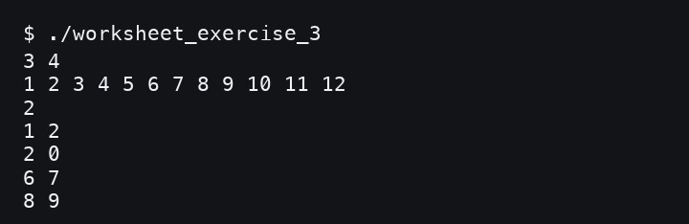
Screenshot of the Output
- Result
The required grid positions were found correctly from the row-major one-dimensional storage.

Problem 4 - Server Response Pairing

Problem Statement
Aarav is optimizing a network load balancer. He has a sorted list of server response times and needs to identify whether exactly two servers have a combined response time equal to the target duration T. If a valid pair exists, he must print the two response times in ascending order. If no such pair exists, he should report that no pair was found.
The problem can be solved in O(n) time using the two-pointer technique.

Input Format
- The first line contains two space-separated integers n and T, the number of elements and the target sum.
- The second line contains n space-separated integers representing the sorted array.

Output Format
- If a pair is found, print Pair Found: X and Y.
- If no pair is found, print No Pair Found.

Code Constraints
- 2 <= n <= 100000
- The array is sorted in non-decreasing order.
- Every element and T fit within a 32-bit signed integer.

Sample Test Cases

Input 1:
6 3
-3 -1 0 2 4 9

Output 1:
Pair Found: -1 and 4

Input 2:
5 10
1 2 4 5 7

Output 2:
No Pair Found

Solution

Aim
To write a C program that checks whether two values in a sorted array add up to a target value using the two-pointer method.

Pseudocode
START
Read n, target T, and the sorted array.
Set left to the first index and right to the last index. Find the sum of the two pointed values.
If the sum equals T, print the pair.
If the sum is less than T, move left forward.
If the sum is greater than T, move right backward. If the pointers cross, print No Pair Found.
END

C Program
#include <stdio.h>

int main(void) { int n, target;
scanf("%d %d", &n, &target);

int arr[100000];
for (int i = 0; i < n; i++) { scanf("%d", &arr[i]);
}

int left = 0, right = n - 1; while (left < right) {
int sum = arr[left] + arr[right];

if (sum == target) {
printf("Pair Found: %d and %d\n", arr[left], arr[right]); return 0;
} else if (sum < target) { left++;
} else {
right--;
}
}

printf("No Pair Found\n"); return 0;
}

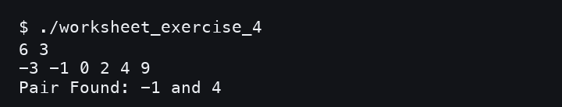
Screenshot of the Output
- Result
The program successfully found a valid pair whose sum matched the target value.

Problem 5 - Compacting Sensor Logs

Problem Statement
Priya collects temperature logs from a sensor that sometimes reports the same reading several times in a row. The log values are already sorted in non-decreasing order. She wants to compact the array in place so that each distinct value appears exactly once, while preserving the order.

Input Format
- The first line contains an integer n, the number of readings.
- The second line contains n space-separated integers, the sorted readings.

Output Format
- On the first line, print k, the number of distinct values.
- On the second line, print the k distinct values in order.

Code Constraints
- 1 <= n <= 100000
- The array is sorted in non-decreasing order.
- The compaction must use O(1) extra space with an in-place two-pointer approach.

Sample Test Cases

Input 1:
9
2 2 3 5 5 5 8 9 9

Output 1:
5
2 3 5 8 9

Input 2:
4
7 7 7 7

Output 2:
1
7

Solution

Aim
To write a C program that removes duplicate values from a sorted array in place and prints only the distinct readings.

Pseudocode

Read n and the sorted array. Set slow = 0.
Move fast from index 1 to n - 1.
Whenever a new distinct value is found, move slow and copy that value there. The number of distinct values is slow + 1.
Print the count and the compacted array.

C Program
#include <stdio.h>

int main() {
scanf("%d", &n); int arr[100000];
for (int i = 0; i < n; i++) {
scanf("%d", &arr[i]);
}

int slow = 0;
for (int fast = 1; fast < n; fast++) { if (arr[fast] != arr[slow]) {
slow++;
arr[slow] = arr[fast];
}
}

int k = slow + 1; printf("%d\n", k);
for (int i = 0; i < k; i++) { printf("%d", arr[i]);
if (i < k - 1) {
printf(" ");
}
}
printf("\n"); return 0;
}

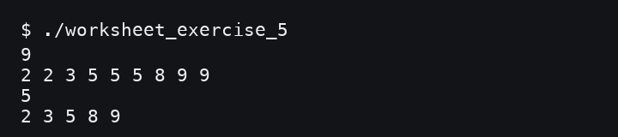
Screenshot of the Output
- Result
The duplicate readings were removed in place, leaving only the distinct values in sorted order.

